**深圳市锐明技术股份有限公司**

**Shenzhen Streamax Technology Co., Ltd.**

**2025届秋季校园招聘简章**

**Recruitment Brochure for the Autumn 2025 Campus Recruitment**

全球车载监控视频占有率第一、商用车行业车联网视频监控产品全球安装量第一的集AI、大数据为一体的商用车安全及信息化解决方案提供商——锐明技术，期待你的加入！

马上登录锐明技术官方招聘网站https://streamax.zhiye.com/campus了解详情吧！

Join Streamax Technology, the leading provider of AI and big data integrated solutions for commercial vehicle safety and informatization, with the highest global market share in onboard monitoring videos and the highest global installation volume of commercial vehicle IoT video monitoring products. We look forward to having you on board!

Visit our official recruitment website at https://streamax.zhiye.com/campus for more details!

**【公司简介】【Company Introduction】**

锐明技术（股票代码002970）创立于2002年，是以人工智能为核心的商用车安全及信息化解决方案提供商。公司现有员工2300余人，其中研发人员800余人。截至目前，公司已在深圳、重庆、北京、成都等地均设有技术研发中心，研发投入连续多年保持在收入总额的12%以上。

Streamax Technology (stock code: 002970) was founded in 2002 and is a leading provider of safety and informatization solutions for commercial vehicles, with artificial intelligence at our core. The company has more than 2,300 employees, including over 800 R&D personnel. Currently, the company has established R&D centers in Shenzhen, Chongqing, Beijing, and Chengdu, with R&D investment consistently exceeding 12% of total revenue.

公司以深圳为中心，辐射国内30多个省市以及北美、欧洲、中东等地，建立起以子公司、办事处等为载体的营销和售后服务体系。产品和解决方案广泛应用于全球100多个国家和地区，成功为北京奥运会、上海世博会、全国两会、北京公交、深圳出租、美国校车、土耳其出租、印度公交、厄瓜多尔综合交通等大型交通安保项目提供安全保障及信息化服务。

With our headquarters in Shenzhen, the company has established a marketing and after-sales service system covering over 30 provinces and cities in China, as well as North America, Europe, the Middle East, and other regions through subsidiaries and offices. Our products and solutions are widely applied in over 100 countries and regions worldwide, providing security and informatization services for major transportation security projects such as the Beijing Olympic Games, Shanghai World Expo, national conferences, Beijing public transportation, Shenzhen taxis, American school buses, Turkish taxis, Indian public transportation, and comprehensive transportation in Ecuador.

**【研发实力】【R&D Strength】**

800余人的专业研发团队，深圳、重庆、成都、北京分别设立研发中心；

属于国家级高新技术企业、深圳软件行业协会会员单位；

深圳市发改委颁发“深圳市人工智能工程中心”，聚焦构建商用车全场景智能安全解决方案；

研发投入占营业收入的12%左右，已经拥有授权专利300余项；

With a professional R&D team of over 800 members, Streamax has established R&D centers in Shenzhen, Chongqing, Chengdu, and Beijing.

The company is a national high-tech enterprise and a member of the Shenzhen Software Industry Association.

Streamax was awarded the "Shenzhen Artificial Intelligence Engineering Center" by the Shenzhen Development and Reform Commission, focusing on building intelligent safety solutions for commercial vehicles in all scenarios.

R&D investment accounts for approximately 12% of operating revenue, and the company already holds over 300 authorized patents.

**【招聘岗位】【Job Openings】**

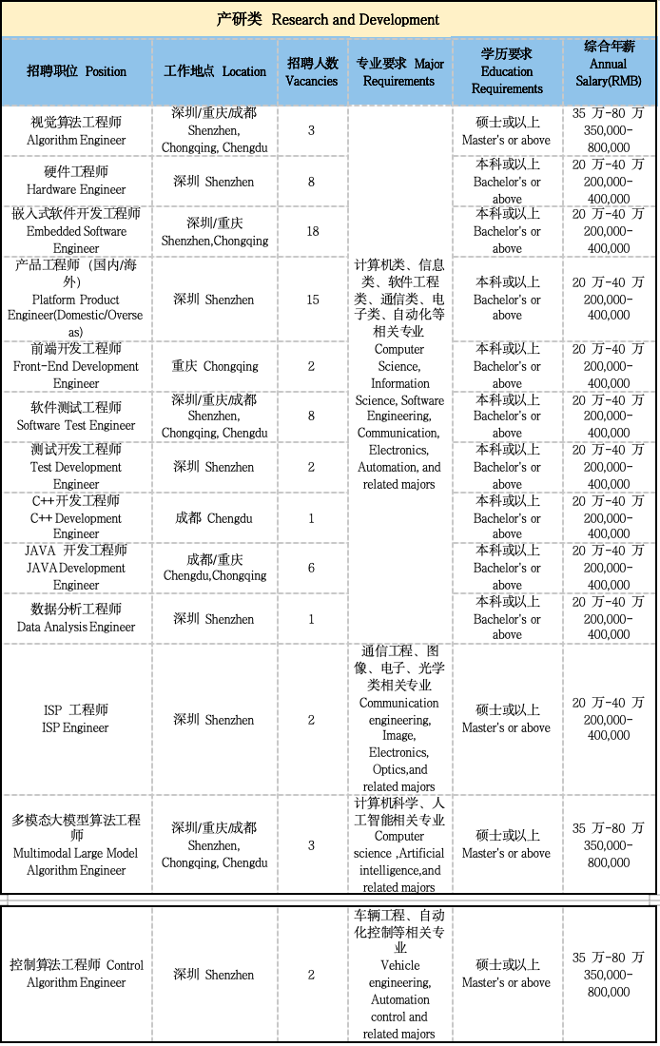

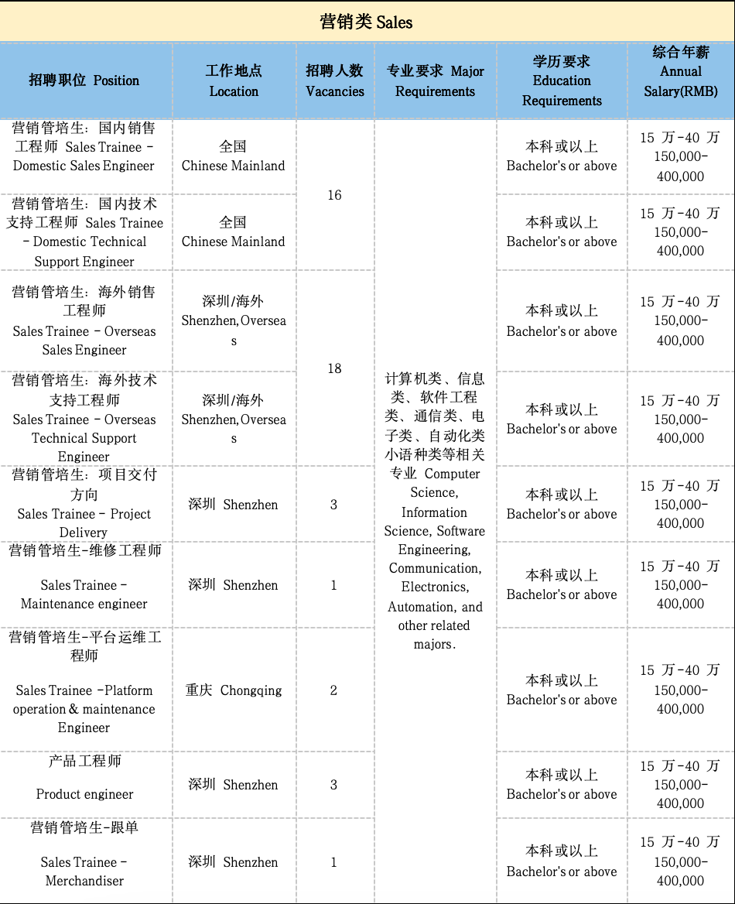

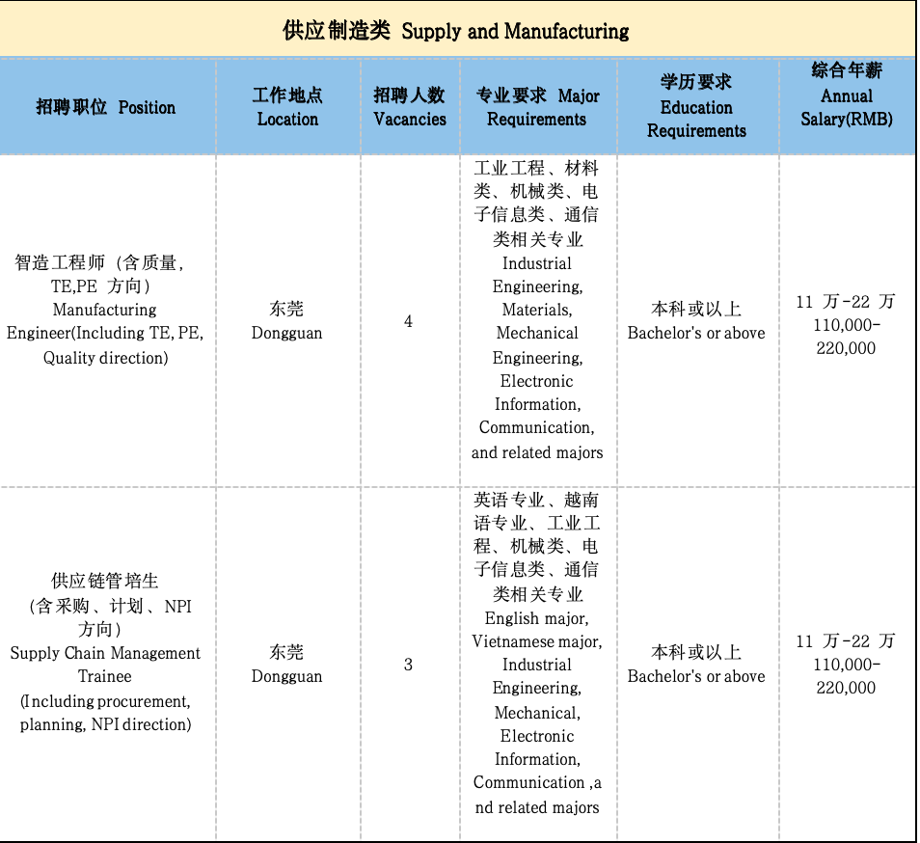

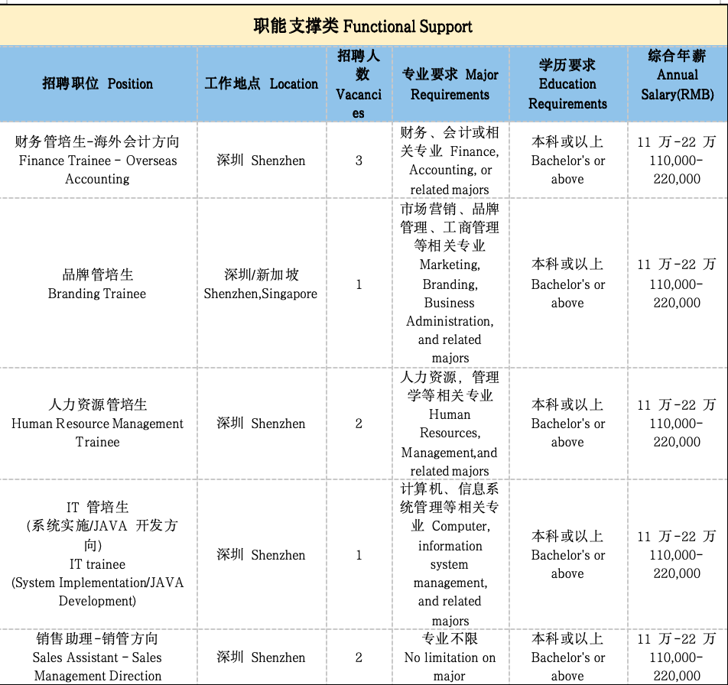

**【招聘对象】【Target Student】**

2024届,2025届国内本科、硕士应届毕业生（毕业时间：2024.1.1-2025.12.31）

Domestic undergraduate and master's students graduating in 2024，2025 (Graduation period: January 1, 2024 - December 31, 2025)

2023-2025届海外留学生/在华国际生（毕业时间：2023.10.1-2025.12.31）

Overseas students studying abroad/in China from 2023 to 2024 (Graduation period: October 1, 2023 - December 31, 2025)

**【工作地点】【Work Locations】**

深圳、重庆、成都、东莞等全国地区，美国、英国、荷兰、墨西哥、巴西等海外地区。

Shenzhen, Chongqing, Chengdu, Dongguan and other national regions, the United States, the United Kingdom, the Netherlands, Mexico, Brazil and other overseas regions。

备注：海外技术支持/海外销售工程师前6个月在深圳总部培养，6个月后工作地点在海外。

Note: For overseas technical support/sales engineers, the first 6 months will be based in Shenzhen for training, and the work location will be overseas after 6 months.

**【招聘流程】**【Recruitment Process】

网申→简历筛选→笔试→面试→签约

Online application → Resume screening → Written test → Interview → Contract signing

**【投递方式】【Application Methods】**

①PC端：<https://streamax.zhiye.com/campus>

① PC: https://streamax.zhiye.com/campus

②微信公众号：关注【锐明招聘】或直接扫描下方二维码

② WeChat Official Account: Follow "锐明招聘" or scan the QR code below



③邮箱投递：[zp@streamax.com](mailto:zp@streamax.com)

③ Email application: zp@streamax.com

注：简历投递至邮箱标题请注明：学校＋专业＋学历＋姓名＋意向职位

Note: Please indicate in the email subject line: School + Major + Degree + Name + Desired position when submitting your resume.

**【福利待遇】**【Benefits and Compensation】

在锐明，你的每一份努力都不会被辜负。

At Streamax, your efforts will never go unrewarded.

* 竞争力的薪酬Competitive Salary:
* 我们密切关注市场薪资状况，每年及时调整薪资政策，以保证具有竞争力的薪资水平；

We closely monitor the market salary conditions and adjust our salary policies annually to ensure competitive compensation levels.

* 公司构建以战略为导向基于价值管理的绩效管理体系，根据员工的绩效结果和目标达成发放奖金；

We have a performance management system based on strategic value management, where bonuses are distributed based on employee performance results and goal achievement.

* 为激发员工最大的工作潜能和效能，设立不同的激励方式:如专项奖金、业绩奖金、年终奖金、技术发明专利奖金、技术创新奖励以及股票分红等中长期激励；

We offer various incentives to maximize employee potential and effectiveness, such as special bonuses, performance bonuses, year-end bonuses, technology invention patent bonuses, technological innovation rewards, and stock dividends for medium to long-term incentives.

* 丰富的福利保障Comprehensive Welfare Benefits:
* 为员工提供各类补贴：午餐补贴、通讯补贴、电脑补贴、出差补贴、驻外区域补贴、驻外住房补贴、海外出差艰苦补贴等；

We provide various subsidies to employees, including lunch subsidies, communication subsidies, computer subsidies, travel subsidies, expatriate allowances, housing allowances for employees stationed abroad, and hardship allowances for overseas business trips.

* 为符合条件的员工提供免息购房借款，为员工成家置业提供有力经济支持

Qualified employees are eligible for interest-free home purchase loans, providing strong economic support for employees to settle down and start a family.

* 全面的保险防护Comprehensive Insurance Coverage:
* 公司为员工缴纳养老、医疗、工伤、失业、生育保险以及住房公积金，给员工提供安心的社会保障。同时还提供商业意外保险，保障员工的人身及财产安全。

We cover employees’ pension, medical, work-related injury, unemployment, maternity insurance, and housing provident fund, providing employees with comprehensive social security. We also provide commercial accident insurance to ensure the personal and property safety of employees.

* 人性化的带薪休假Paid Vacation:
* 为了保障员工的工作与生活平衡，我们提供了多样的带薪假期：年假、婚假、产假、陪产假等，另法定假日：春节、清明、五一、端午、中秋、国庆、元旦均按国家政策要求放假

To ensure a work-life balance, we offer various paid vacations, including annual leave, marriage leave, maternity leave, paternity leave, etc. Additionally, we observe national holidays such as Chinese New Year, Tomb-Sweeping Day, Labor Day, Dragon Boat Festival, Mid-Autumn Festival, National Day, and New Year's Day as required by national policies.

* 综合的健康保障Comprehensive Health Protection:
* 我们为员工提供一年一度的身体健康检查，全面检测大家的身体状况，尽早预防各类健康风险。

We provide annual physical health examinations for employees to comprehensively assess their health conditions and proactively prevent health risks.

* 贴心的后勤服务Thoughtful Logistics Services:
* 丰富的节日慰问礼品：如端午节、中秋节等的节日礼品；

We offer a variety of holiday gift packages, such as gifts for festivals like Dragon Boat Festival and Mid-Autumn Festival.

* 为符合深圳入户政策及公司落户政策的员工办理落户手续；

We assist eligible employees in handling household registration procedures in accordance with the Shenzhen household registration policy and company registration policy.

* 结婚礼金、生育贺礼、女性员工三八节专属福利……

We provide wedding gifts, birth congratulations, and exclusive benefits for female employees on International Women's Day.

* 六一儿童节、程序员节特别专题活动……

Special events are organized for Children's Day and Programmer's Day.

**【联系方式】【Contact Information】**

公司地址Company Address：

深圳：深圳市南山区学苑大道1001号南山智园Bl栋21-23楼

Shenzhen: Building B1, 21-23/F, Nanshan Intelligence Park, No.1001, Xueyuan Avenue, Nanshan District, Shenzhen.

重庆：重庆市九龙坡区科园一路166号火炬大厦2号楼12-2、12-3

Chongqing: 12-2, 12-3, Torch Building, No.166, Keyuan 1st Road, Jiulongpo District, Chongqing.

东莞：广东省东莞市清溪镇青滨东路105号力合紫荆智能制造中心20栋

Dongguan: Building 20, Lihe Zijing Intelligent Manufacturing Center, No.105, Qingbin East Road, Qingxi Town, Dongguan City, Guangdong Province.

成都：成都市双流区湖畔路西段99号天府菁蓉中心d区b1栋

Chengdu: Building B1, Area D, Tianfu Jingrong Center, No.99, West Section of Hupan Road, Shuangliu District, Chengdu City.

联系方式Contact Information:

联系电话Phone：0755 - 3360 1988

简历投递邮箱Email：[zp@streamax.com](mailto:zp@streamax.com)

**锐明技术校招组**

**Streamax Technology Campus Recruitment Team**

**2024年8月**

**August , 2024**